H.T No
Regulations:
A22

Sreenidhi Institute of Science and Technology
(An Autonomous Institution)
Code No: 9B201 Date: 30-Aug-2023 (FN)

B.Tech I-Year II- Semester External Examination, Aug/Sept-2023 (Regular)
ENGINEERING MECHANICS (ME)

Time: 3 Hours Max.Marks:60

Note: a) No additional answer sheets will be provided.
b) All sub-parts of a question must be answered at one place only, otherwise it will not be valued.
c) Missing data can be assumed suitably.
Bloom's Cognitive Levels of Learning (BCLL)

Remember | L1 | Apply | L3 | Evaluate | L5
Understand | L2 | Analyze | L4 | Create | L6

Part - A Max.Marks: 6x2=12

Answer all QUESTIONS, EACH QUESTION CARRIES 2 MARKS.

 |  | BCLL | CO(s) | Marks
1 | What is meant by Free Body Diagram? | L2 | CO1 | [2M]
2 | What are the methods of analysis of Perfect Frames? | L1 | CO2 | [2M]
3 | Distinguish between centriod and centre of gravity | L4 | CO3 | [2M]
4 | Define the terms polar moment of inertia and product of inertia? | L1 | CO4 | [2M]
5 | Define Translation. | L1 | CO5 | [2M]
6 | State work - energy method and write the equation | L1 | CO6 | [2M]

Part – B Max.Marks: 6x8=48
ANSWER ALL QUESTIONS. EACH QUESTION CARRIES 8 MARKS.

 |  |  | BCLL | CO(s) | Marks
7. | a) | 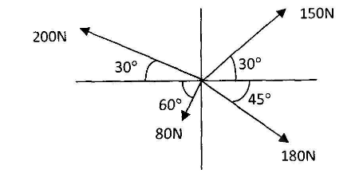  Determine the resultant of concurrent forces shown in the figure below | L5 | CO1 | [8M]
 |  | OR
 | b) | Determine the forces P,F and T required to keep the triangular frame ABC shown figure is in equilibrium.  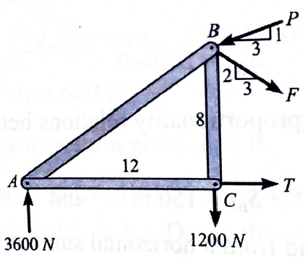 | L5 | CO1 | [8M]
8. | a) | 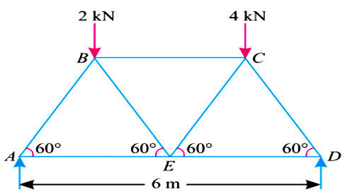  Determine the forces in the all the members of the truss and as shown below figure and tabulate the results. | L5 | CO2 | [8M]
 |  | OR
 | b) | Find the least horizontal force P to start motion of any part of the system of three blocks resting upon one another as shown in figure. The weights of the blocks are W_{A} = 300 N, W_{B} = 100 N, and W_{C}= 200 N Between A and B µ = 0.3, between B and C µ = 0.2, and between C and the ground µ = 0.1.  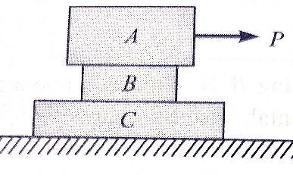 | L3 | CO2 | [8M]
9. | a) | 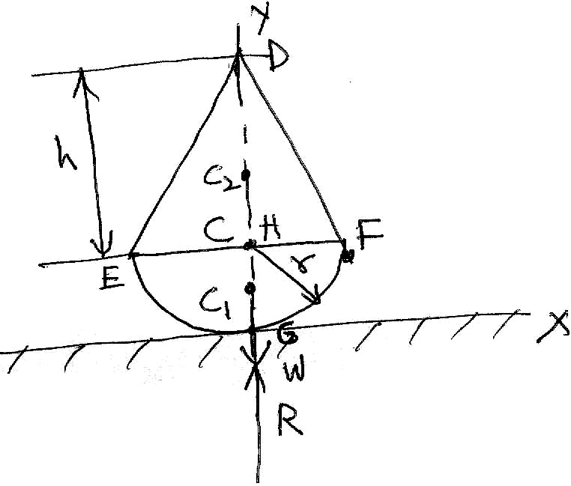  A body is made up of a hemisphere and a cone each of radius "r" as shown in figure. The hemispherical surface of the body rests on a horizontal plane. . Find the greatest height of the cone, so that the combined body may stand upright. | L3 | CO3 | [8M]
 |  | OR
 | b) | Locate the centroid C of the shaded area obtained by cutting a semi circle of dia ‘a’ from the quadrant of a circle of radius ‘a’ as shown in Fig.  60  60  60  y  x  Fig. | L3 | CO3 | [8M]
10. | a) | Determine the area moment of inertia of a rectangle with dimensions b x h about the base b. | L5 | CO4 | [8M]
 |  | OR
 | b) | Determine the mass moment of inertia of a solid sphere of radius "R" about its diametral axis. | L5 | CO4 | [8M]
11. | a) | Two guns are pointed at each other one upward at an angle 30º and the other at the same angle of depression, the muzzles being 20 m apart. If the guns are shot with velocities of 350 m/s upwards and 300 m/s downwards respectively. Find when and where they will meet? | L3 | CO5 | [8M]
 |  | OR
 | b) | 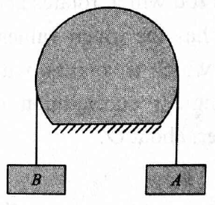  Referring to Fig assume A weigh 900 N B weighs 300N. Determine the acceleration of the bodies if the coefficient of kinetic friction is 0.1 between the cable and the fixed drum. | L5 | CO5 | [8M]
12. | a) | Two balls of equal mass and of perfectly elastic material are lying on the floor. One of the ball with velocity v is made to struck the second ball. With what a velocity both the balls after impact will move? | L5 | CO6 | [8M]
 |  | OR
 | b) | 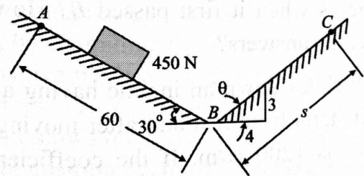  As shown in Fig. a 450 N body moves along the two inclines for which the coefficient of friction is 0.2. If the body starts from rest at A and slides 60 m down the 30º incline, how far will it then move along the other incline? What will be its velocity when it returns to B? | L3 | CO6 | [8M]

-- 00 -- 00 –

